

SCHOOL OF COMPUTER SCIENCE
AND ARTIFICIAL INTELLIGENCE
DEPARTMENT OF COMPUTER SCIENCE

Assignment Type: Lab
Academic Year:2025-2026
Course Coordinator Name:- Dr. Rishabh Mittal
STUDENT NAME:-Pentapuri yeshwanth
ENROLLMENT NUMBER:-2403A51l39
SUBJECT NAME:- AI Assisted Coding
COURSE CODE:-23CS201PE401
YEAR/SEM :- III/II
BATCH:-52

TASK
Assignment submission starts from here

TASK :-1 Smart Contact Manager (Arrays & Linked Lists)
Prompt:- Act as a Data Structures expert.

Create a Smart Contact Manager for SR University’s student club using:

1) Array (list) implementation
2) Linked List implementation

Each contact should store:
- Name
- Phone number

Implement:
- Add contact
- Search contact
- Delete contact

Add inline comments and make it menu-driven.
Handle edge cases (empty list, not found).

Finally, compare the Array vs Linked List in terms of:
- Insertion efficiency
- Deletion efficiency
- Time complexity (Big-O)
- Memory usage

Code

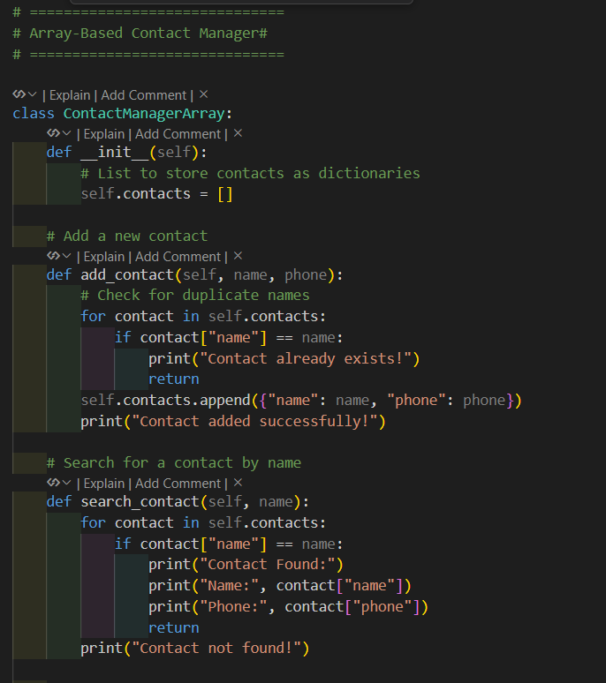

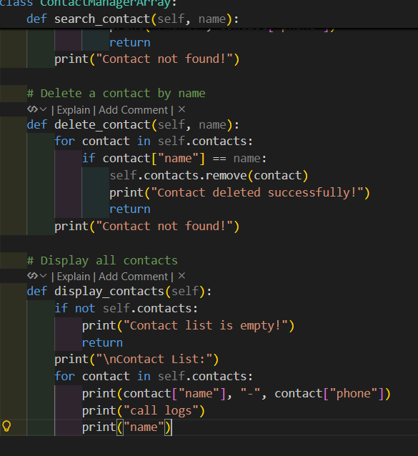

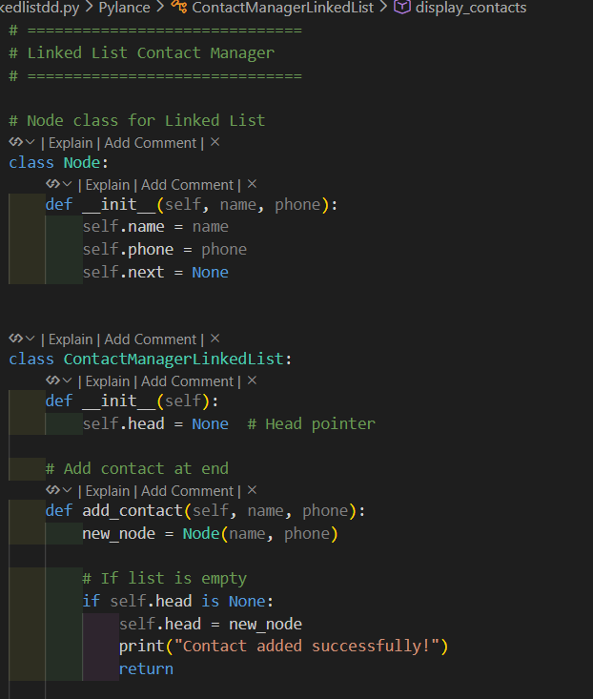

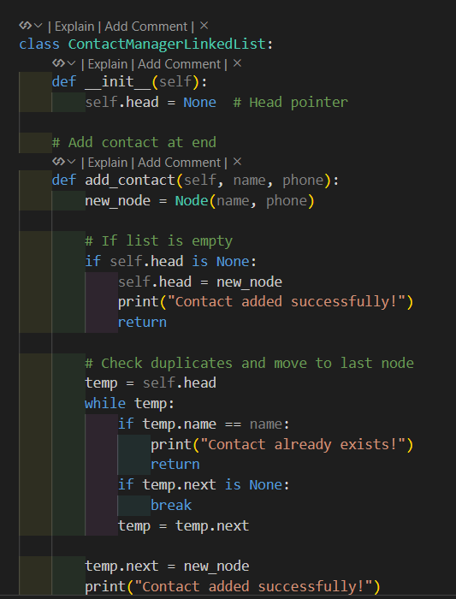

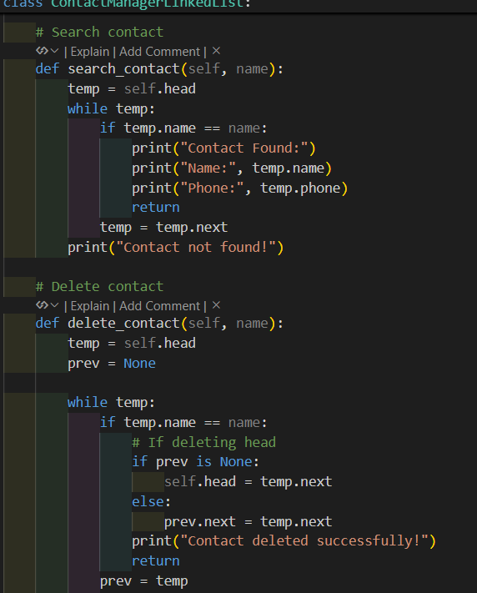

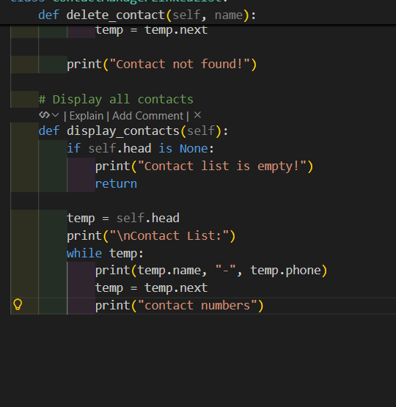

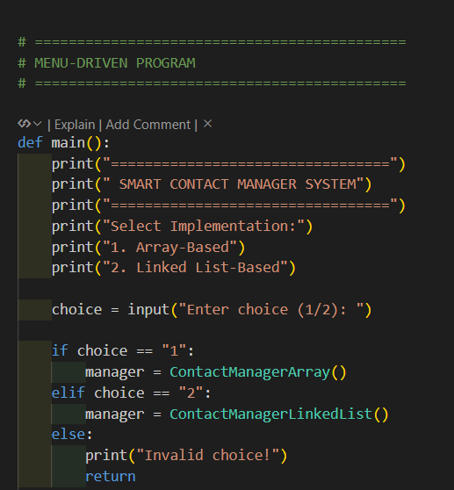

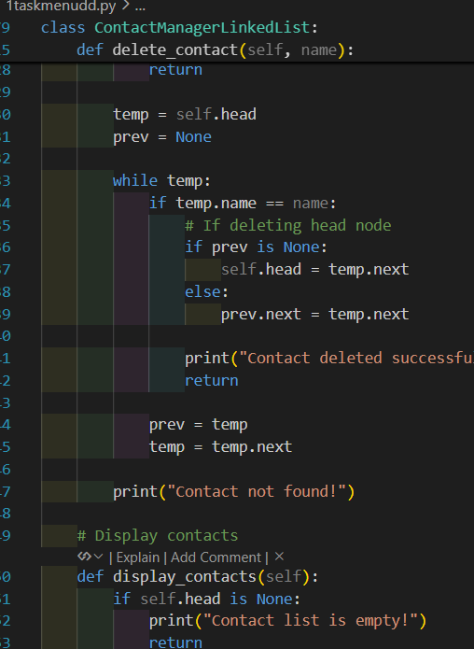

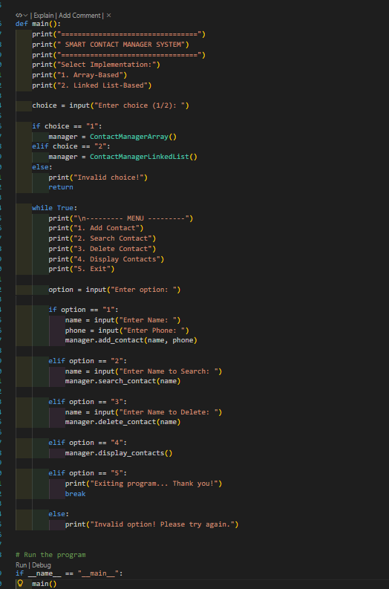

OUT PUT:-
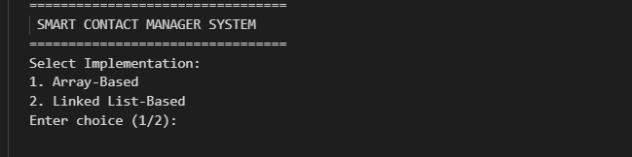

EXPLIN

- Implemented Contact Manager using Array and Linked List
The program was developed using two data structures. In the array method, contacts are stored in a list. In the linked list method, contacts are stored as nodes connected through pointers.
•2. Performed Add, Search, and Delete operations (Search = O(n))
The system allows adding new contacts, searching contacts by name, and deleting contacts. Searching requires checking each element one by one, so its time complexity is O(n).
•3. An array is simple; a linked list supports dynamic memory but uses extra space
The array implementation is easy to use and efficient for small data. The linked list allows dynamic memory allocation but requires extra memory to store pointers between nodes.

Task 2: Library Book Search System (Queues & Priority Queues)
Scenario
The SRU Library manages book borrowing requests. Students and faculty submit
requests, but faculty requests must be prioritised over student requests.

Prompt:-
Act as a Data Structures expert.

Create a Library Book Borrow Request System using:
1) Normal Queue (FIFO)
2) Priority Queue (Faculty has higher priority than Students)

Each request should store:
- Name
- Role (Student/Faculty)
- Book Name

Implement:
- Add request
- Process next request
- Display pending requests

Faculty requests must be processed first.
Add inline comments and make it menu-driven.

Finally, compare Queue vs Priority Queue with time complexity.

CODE:-
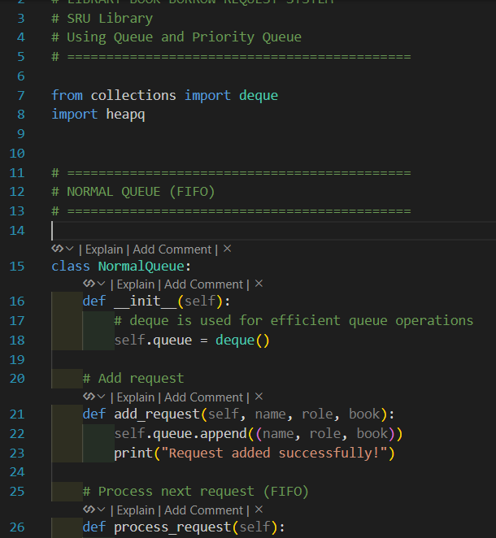

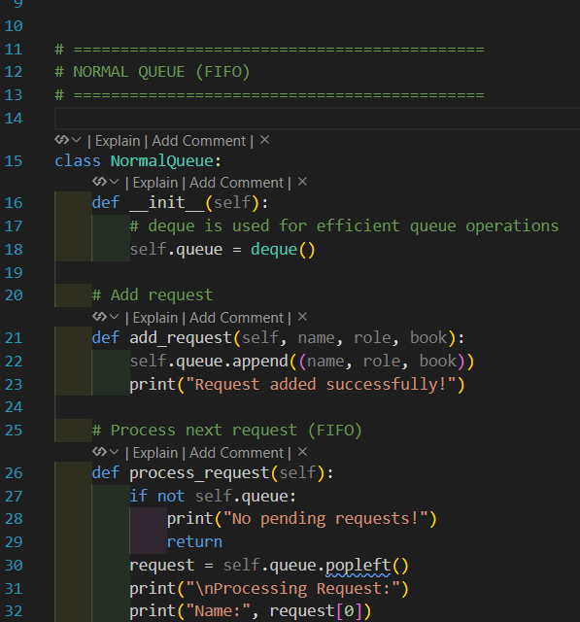

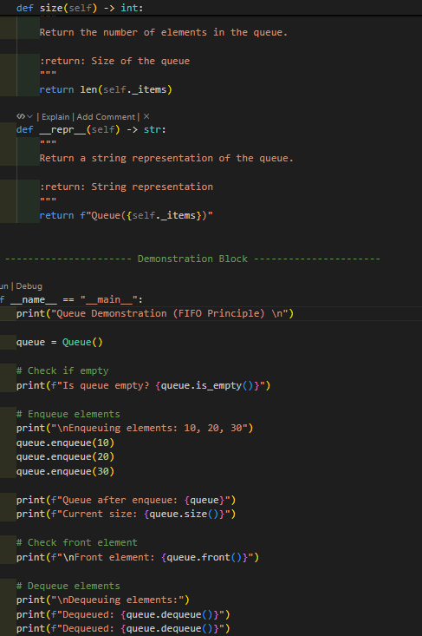

OUTPUT:-

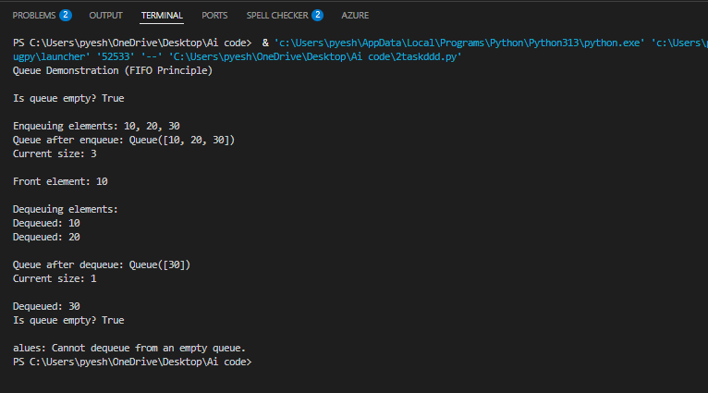
explanation

- Implemented using Queue and Priority Queue
The system was developed using two data structures: a Normal Queue (FIFO) and a Priority Queue where faculty requests are given higher priority.
- Add Request Operation
Each borrow request stores Name, Role (Student/Faculty), and Book Name. Requests are added to the queue or priority queue accordingly.
- Process Request Operation
In the Normal Queue, requests are processed in First-In-First-Out order.
In the Priority Queue, Faculty requests are processed before Student requests.
- Display Pending Requests
The system shows all pending borrow requests currently waiting in the queue.
- Performance Difference
Normal Queue operations take O(1) time, while Priority Queue operations take O(log n). Priority Queue is more suitable when certain requests need higher importance.

TASK :- 3 Emergency Help Desk (Stack Implementation

Prompt:- Act as a Data Structures expert.

Create an Emergency IT Help Desk system using Stack (LIFO).

Implement:
- push(ticket)
- pop()
- peek()
- isEmpty()
- isFull() (if fixed size)

Each ticket should store Ticket ID, Name, and Issue.

Simulate at least 5 tickets being raised and resolved.
Add inline comments and sample output.

CODE:-
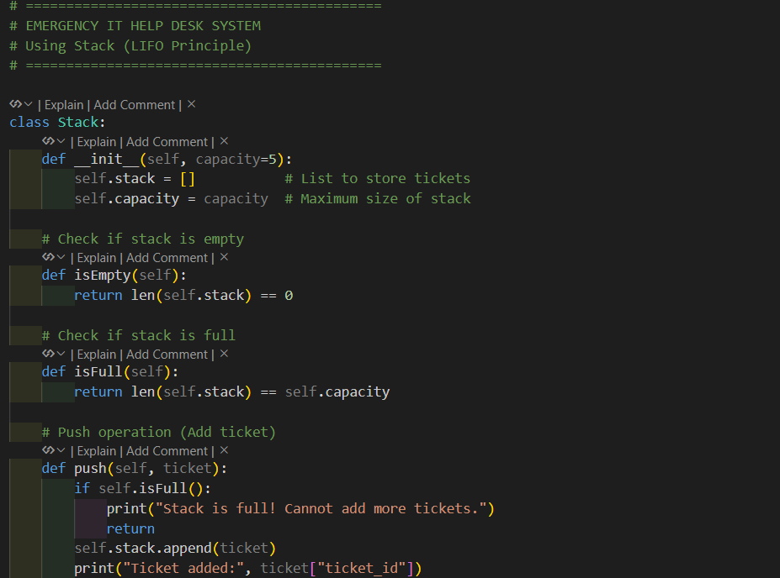
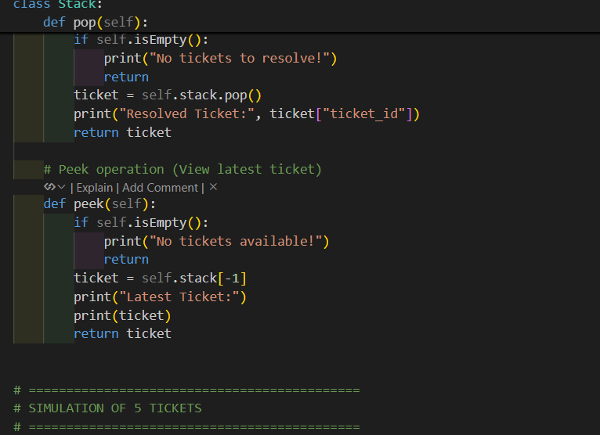

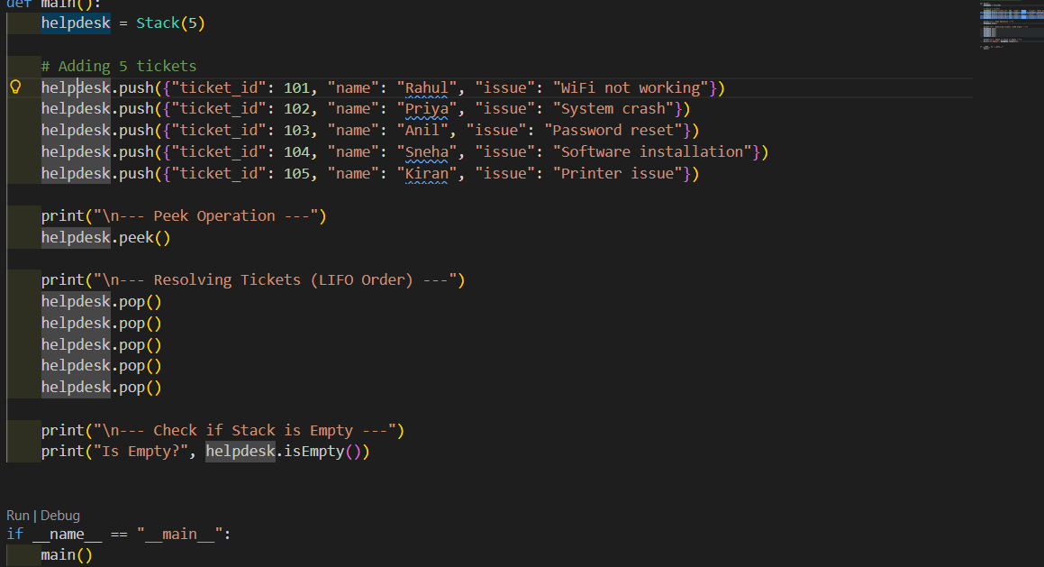

TASK 4 : - Hash Table
Prompt:-
Act as a Data Structures expert.

Complete the following starter code:

class HashTable:
pass

Requirements:

1) Implement a Hash Table using collision handling with chaining (linked list or list inside buckets).
2) Implement the following methods:
- insert(key, value)
- search(key)
- delete(key)
3) Use a proper hash function.
4) Add clear inline comments explaining each step.
5) Handle collisions correctly using chaining.
6) Show sample usage and output.
7) Explain time complexity of each operation.

CODE:-

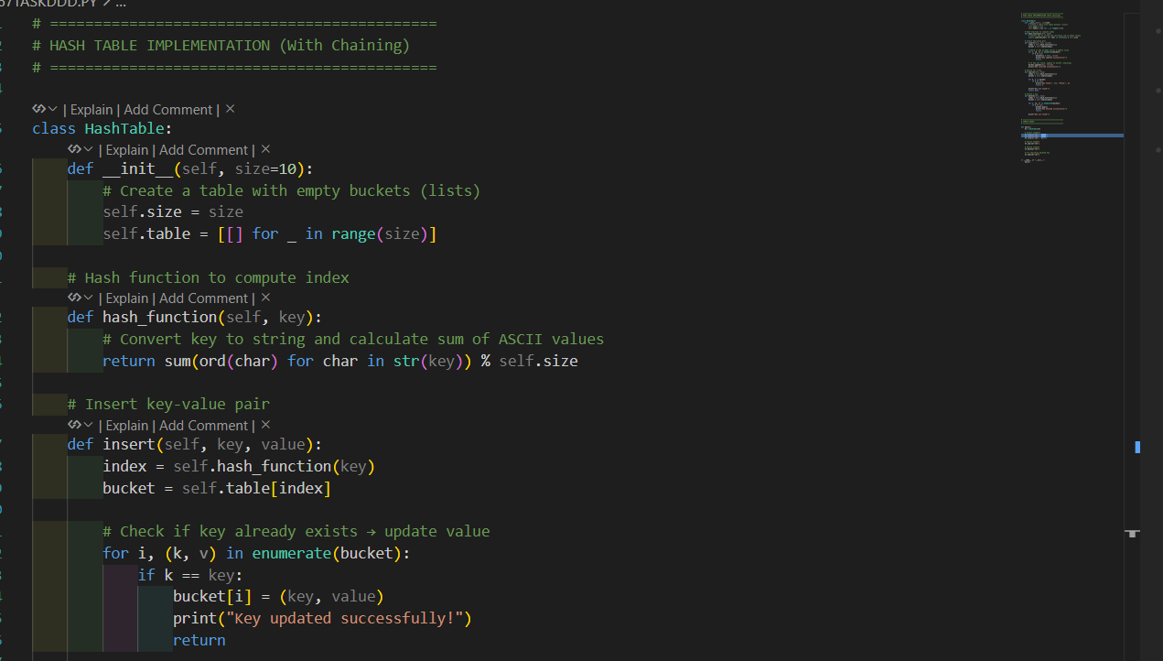

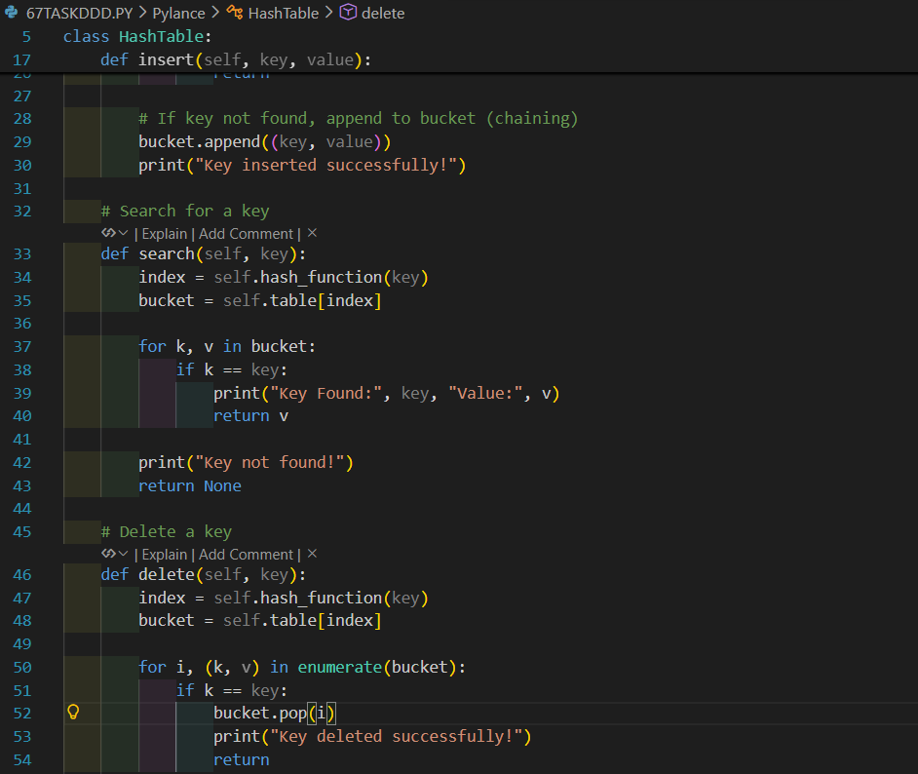

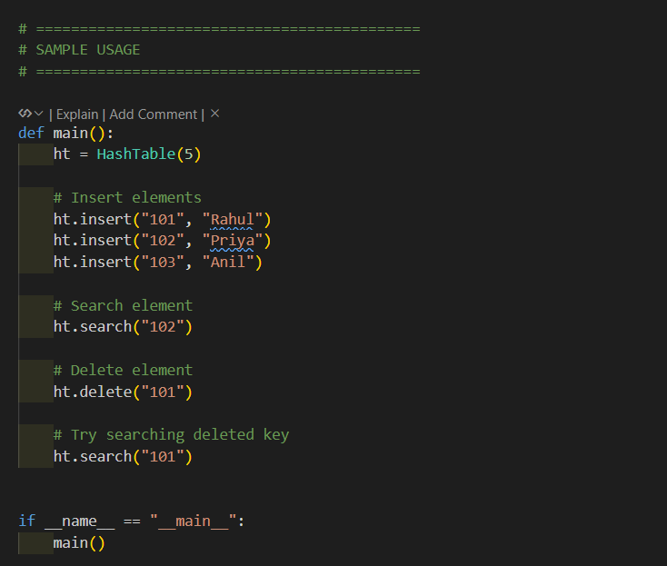

OUTPUT:-
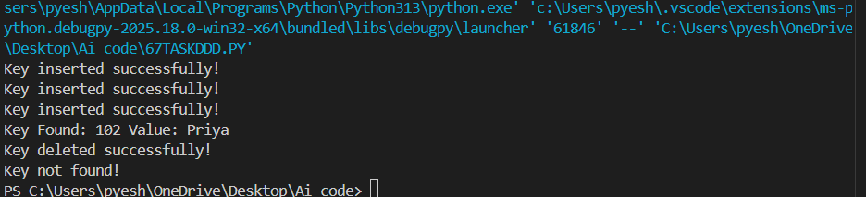
explanation

- Hash Table Structure
A hash table is a data structure that stores key–value pairs. It uses a hash function to convert a key into an index of an array.
- Hash Function
The hash function calculates the index by converting the key into ASCII values and applying modulo with table size. This ensures the key is stored within the table range.
- Collision Handling (Chaining)
When two keys produce the same index, a collision occurs. This is handled using chaining, where multiple key–value pairs are stored in a list at the same index.
- Insert, Search, and Delete Operations
Insert adds a key–value pair to the correct bucket.
Search checks the bucket for the key.
Delete removes the key from the bucket if found.
- Time Complexity
Average case for insert, search, and delete is O(1).
Worst case is O(n) when many collisions occur.

Task 5: Real-Time Application Challenge

Prompt
Act as a Data Structures expert and software developer.

Design a Campus Resource Management System with the following modules:

1) Student Attendance Tracking
2) Event Registration System
3) Library Book Borrowing
4) Bus Scheduling System
5) Cafeteria Order Queue

Requirements:

- Choose appropriate data structures for each module.
- Explain why each data structure is suitable.
- Implement basic operations for each module.
- Add inline comments.
- Show sample usage/output.
- Explain time complexity of operations

CODE:-

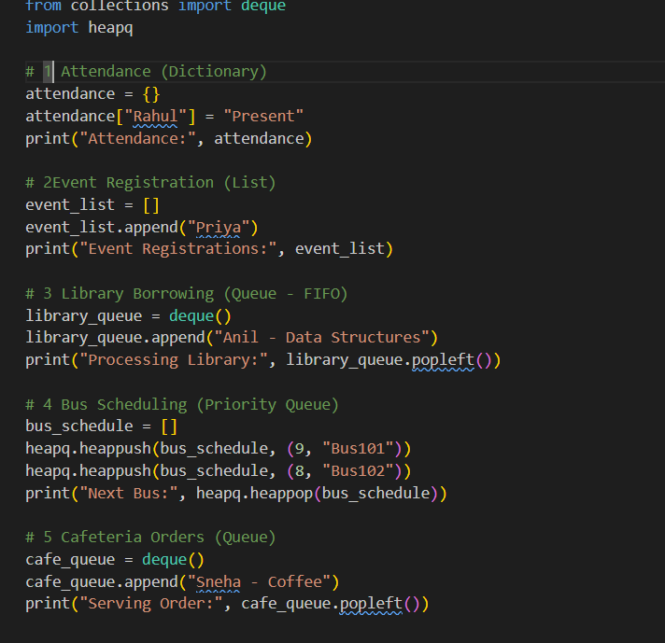

OUTPUT:-

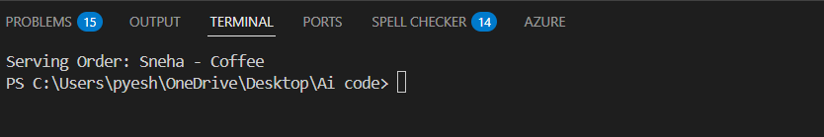

Explanation
- Attendance System uses a Dictionary for fast student record access (O(1)).
- Event Registration uses a List to store registered students.
- Library Borrowing uses a Queue (FIFO) to process requests in order.
- Bus Scheduling uses a Priority Queue to serve earlier time buses first.
- Cafeteria Orders use a Queue to serve customers in arrival order.

